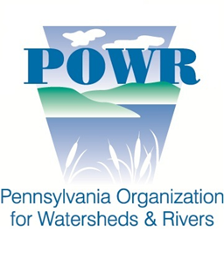
2018 River of the Year Nomination Form

Nominations due Monday, November 6, 2017 by 5 p.m.

Complete this form electronically and email to Angela Vitkoski at avitkoski@pecpa.org by Monday, November 6, 2017 at 5 p.m. Please be sure to include both this nomination form and a high quality resolution photo (300 dpi) of your river/stream. If you have any questions, please contact Angela at (570) 718-6507 or at avitkoski@pecpa.org

Nomination of the enter text here as the 2018 “River” of the Year.
[Name of river or stream]

NOMINATING ORGANIZATION INFORMATION
Nominating Organization: enter text here
Primary Contact Name: enter text here
Street Address: enter text here
City: enter text here
State: enter text here
Zip: enter text here
Phone: enter text here
Email: enter text here
Website: enter text here
Is your organization a 501(c)3 non-profit organization currently registered with the IRS?
☐ Yes ☐ No
Is your organization registered with the PA Department of State Bureau of Charitable Organizations?
☐ Yes ☐ No

RIVER OR STREAM NOMINATION INFORMATION
What river and/or stream are you nominating for 2018 River of the Year: enter text here
In which river basin is your river or stream?
☐ Delaware
☐ Erie
☐ Genesee
☐ Ohio
☐ Potomac
☐ Susquehanna

Based on river miles, access points, and in-stream flow is it feasible to host a one-day and/or overnight sojourn paddling trip on your river or stream?
☐ Yes ☐ No

Please describe your river and/or stream. Also describe the challenges and conservation needs as well as successes attained. Be sure to include any other reasons why your river would be an excellent choice for 2018 River of the Year: enter text here

Please describe your organization and why you would be a good host for the 2018 River of the Year, include organizational capacity and experience: enter text here

No organization can do these activities alone. Please list organizations that you will partner with and what their respective roles will be in carrying out the 2018 River of the Year program? enter text here

Please list examples of the activities that you will undertake throughout the year if selected for the 2018 River of the Year: enter text here

For your nomination to be considered you must include a high-quality resolution photo (300 dpi) of your river or stream. This photo will be used to promote your nomination during the voting process.

